Owner |  | Document
Name |  | Project
E-mail |  | Filename | input.doc

Abstract
Write a short description of the project

Table of Contents
Table of Contents 2
1 Introduction 3
1.1 Background Reading 3
1.2 Glossary 3
1.3 Design Library 3
1.4 People Involved 3
2 General Description 4
3 Pin List 5
4 Functional Description 6
4.1 Overview 6
4.2 Procedural Diagram 6
4.3 Detailed Description 7
4.3.1 Subblock A 7
4.3.2 Subblock B 8
4.3.3 Subblock C 8
5 Implementation 9
5.1 <Subblock_A> (<SUBA>) Subblock 9
5.1.1 Pin List 9
5.1.2 Interface Diagram 10
5.1.3 Description 10
5.1.4 <SUBA> Finite State Machine 11
5.2 <Subblock_B> (<SUBB>) Subblock 13
5.3 <Subblock_C> (<SUBC>) Subblock 13
6 Verification (Optional) 14
6.1 List of Tests 14
6.2 Detailed Test Description 14
6.2.1 Test A 14
6.2.2 Test B 14
6.2.3 Test C 14

Introduction

Background Reading
[1] Write here any resources used when researching for the module (not needed for this class)
[2]

Glossary
i.e:
UART Universal Asynchronous Receiver Transmitter
RX receive
etc…

Design Library
Add design library, <top block>_lib i.e. uart_lib (not needed for this class)

People Involved

Name | E-mail address

General Description
Write a general description of the block. It should include:
- Some theory on where this block is based
- Key equations
- Simple description of the block partitioning

Pin List

Signal | I/O | Description
Clock & Reset
clk | in | System clock.
rst_n | in | Global asynchronous active low reset.
Interface 0
i_signal0 | in | Describe input signal.
Interface 1
i_signal1 | in | Describe input signal.
i_signal2 | in | Describe input signal.
o_signal0 | out | Describe output signal.
Interface 2
i_signal3 | in | Describe input signal.
i_signal4[7:0] | in | Describe input vector.
Interface 3
o_signal1[31:0] | out | Describe output vector.
o_signal2 | out | Describe output signal.

Table 3.1: Input/Output Signals

Functional Description

Overview
The functional description of a module, is the most vital of its design. It is basically the “great idea” part the project. All later designing will be driven by the functional report.
It is basically the abstract idea of “what we need” and “how we will accomplish” it. It should contain all subblocks that the main design will be divided in.
Tip: Although in small projects the naming isn’t a big problem, it becomes a great one, on large projects, with multiple versions and implementations. For this reason, it is advised that the “top” module should have a name 5-6 letters long. Etc “uart_top”. All subblocks should have the “name” of the top module as prefix. etc “uart_transmitter”

The diagram of Figure 4.1 illustrates a single instantiation of <top block>. (This is the <top block> diagram where the Input/Output pins described in Table 3.1 are shown)

Example
Figure 4.1: uart_top
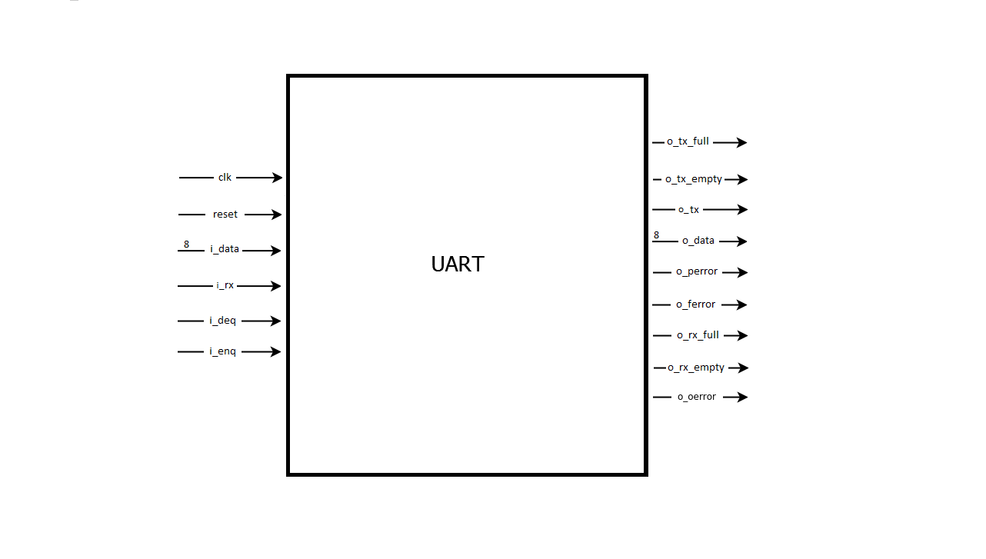

Procedural Diagram
Figure 4.2 depicts the internal subblocks of the <top block> as well as the “abstract” Datapath.
Those are the subblocks that the <top block> diagram is divided in. i.e. <Subblock A>, <Subblock B>… You must show the Input/Output interface of the top block plus the internal interfaces of the subblocks)
You must only depict the data path and the subblocks in that path. Everything else is considered a control signal in this abstract concept. It is not necessary at this stage to specify the name and the exact purpose of every signal. Just the required info to understand the flow of the data.

Example:
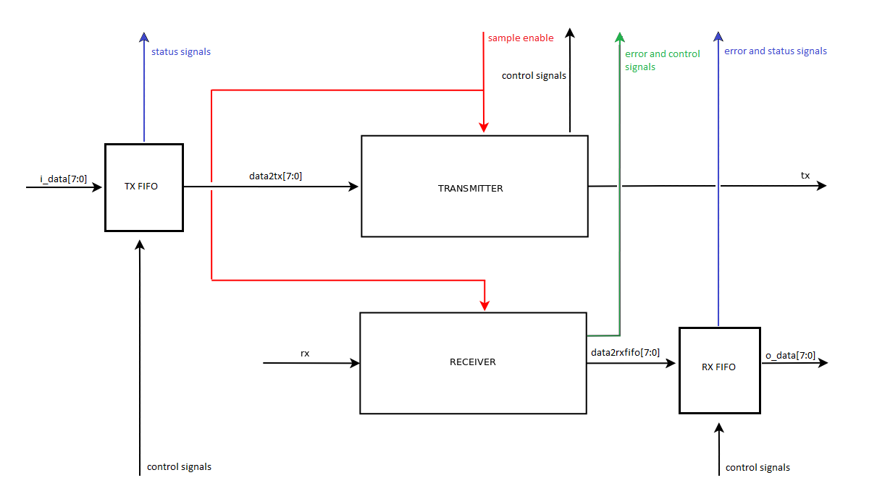
Figure 4.2: Procedural diagram of uart_top

Detailed Description

Subblock A
Give a simple diagram of the internals of Subblock A

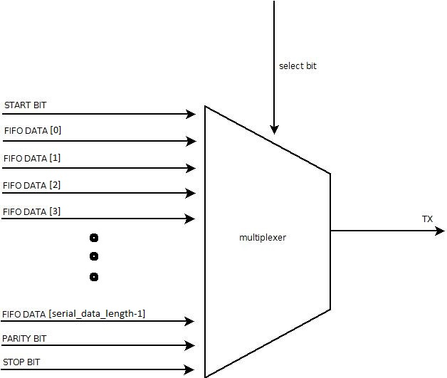
Figure 4.3: uart_transmitter

Analyze the functions implemented in <Subblock A>.
Remember that the functional report has been created before the implementation report (and the verilog code of course), so the analysis of the subblock's function should be made using abstract terms, which means that there must not be any reference to state machines, registers, clocks cycles, etc.
Example:
[…]The transmitter is responsible for serial transmission of data given by the memory. When the transmitter's is idle, the stop-bit is constantly emitted to the serial output of the design. Then, if the input signa “empty FIFO” drops to zero, a sample counter starts increasing its value every time the sample-enable signal rises from the baud controller.
When the maximum value of the counter is reached, a new multiplied sample-enable signal rises, indicating the period of serial transmission of a single bit. Every time the new multiplied sample-enable signal is active, the transmitter emits the next bit of a certain sequence: the start-bit, the data bits, the parity-bit (if parity is enabled) and the stop-bit. At first, the emission of the start-bit means that the value 0 is at the serial output port [...]

It is also advised to give any timing waveforms, that help understand the timing with wich various signals should be driven. (Not required in this class)

Subblock B… C ..
As above

Implementation
The following paragraphs we describe the implementation of the <top block>. Implementation is the part where you describe how the Datapath will actually look like, down to the smallest bits if needed.
A good implementation report is the guideline used to write the Verilog code. Your code should reflect the design described in this document, in order to make the debugging, and sharing easier.

NB: The example analysed in this document does not correspond to a verified design; it is written in such way as to show how a designer could efficiently analyze a block.
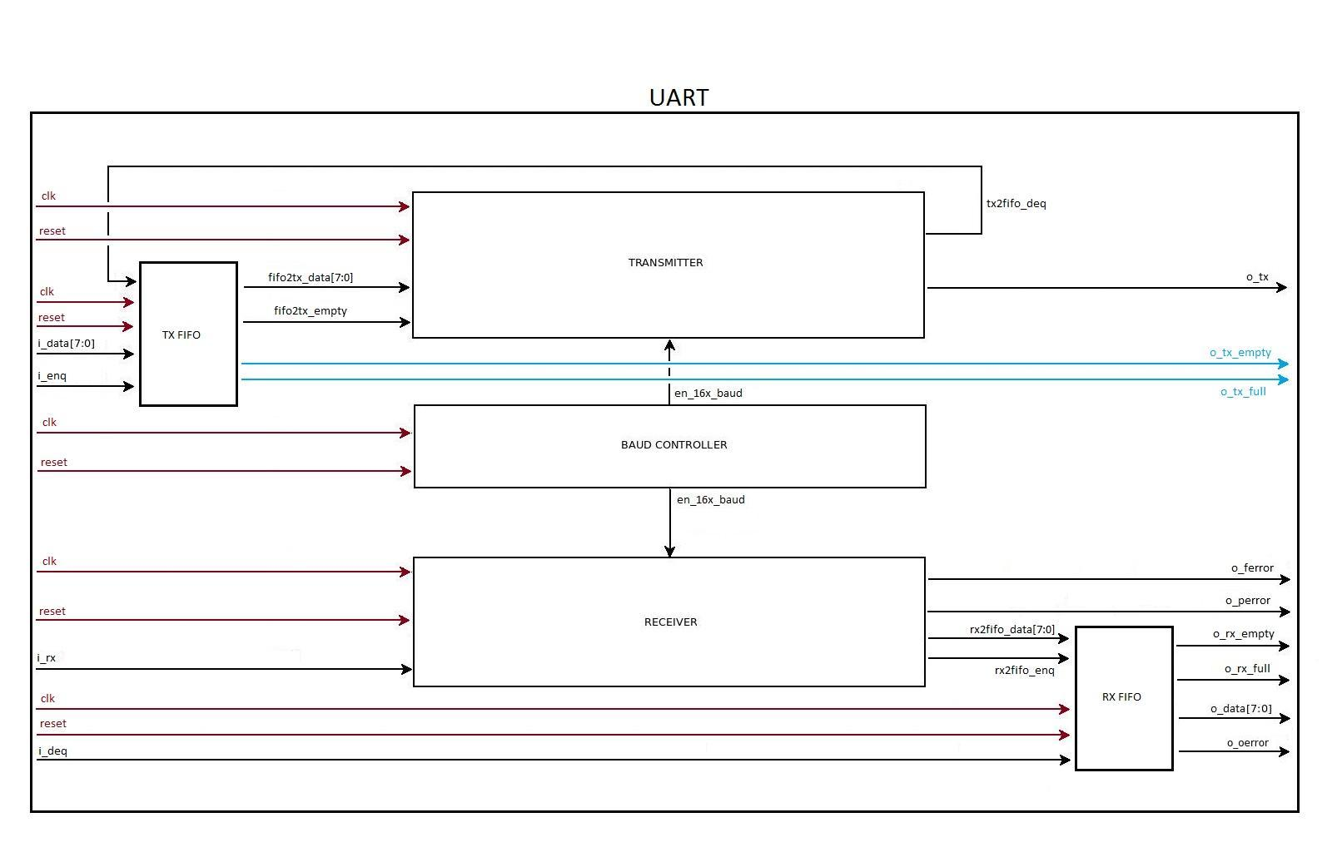
Figure 5.1: Interface Diagram of uart_top module

<Subblock_A> (<SUBA>) Subblock

Pin List
Signal | I/O | Description
Clock & reset
clk | in | System clock.
rst_n | in | Global asynchronous active low reset.
Input interface
i_ip0 | in | Describe input signal.
i_ip3 | in | Describe input signal.
i_s1_sig0 | in | Describe input internal signal.
Output interface
o_s0_sig0 | out | Describe output internal signal.
o_s0_sig1 | out | Describe output internal signal.
Table 5.2: <SUBA> Subblock Pin List

Interface Diagram
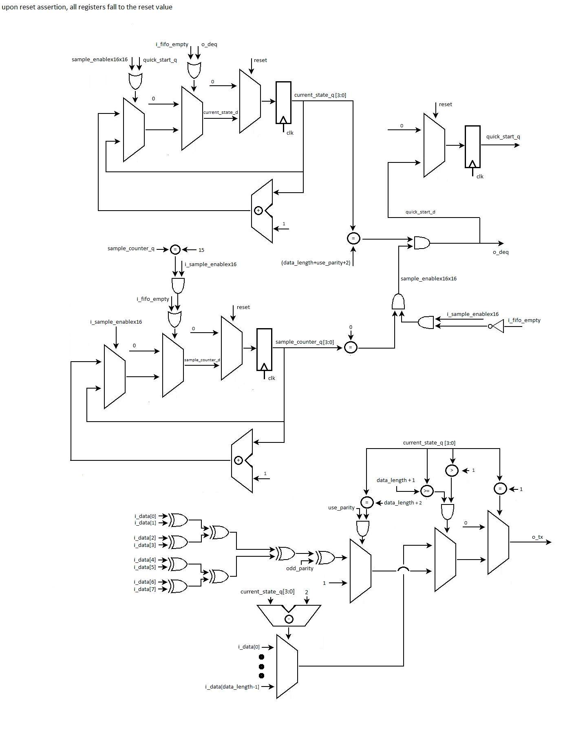
Figure 5.2: Interface Diagram of uart_transmitter

Description
Give a COMPLETE description of what the subblock does.
Then start analysing EVERY BIT OF CODE you intend to write. Each signal generation or assignment MUST be explained and shown within the above figure. The aim here is to describe the design in such manner that it would be possible to recreate the verilog code by reading this report.
Note that registers MUST ALWAYS be named and the resulting signals are named as <register_name>_q, where “_q” denotes the output of this register. Also notice the white box, indicating how the register is reset. This should be included in all figures containing registers or synchronous logic.
Example:
The transmitter has a finite state machine which has as many states as the data-bits that it has to transmit plus the idle state and the start-bit, the stop-bit and - if in parity mode - the parity-bit states. The states' identification is represented by the value stored in the current_state_q register. Transmitter's state machine is initialized to the idle-state and will not switch to the next state if the i_fifo_empty signal is deactivated. Every time the new multiplied sample-enable signal (sample_enablex16x16) has the value '1' the state machine switches to the next state, by adding the value '1' to its previous state number (stored in current_state_q) otherwise it preserves the previous state. When the machine is at the stop-bit state and the dequeue signal is activated (o_deq), the system will return to the idle state and if the memory is not empty, it will switch to the start-bit state after the arrival of the quick_start signal (...)

<SUBA> Finite State Machine
This subblock could introduce state machine, as depicted in Figure 5.6.
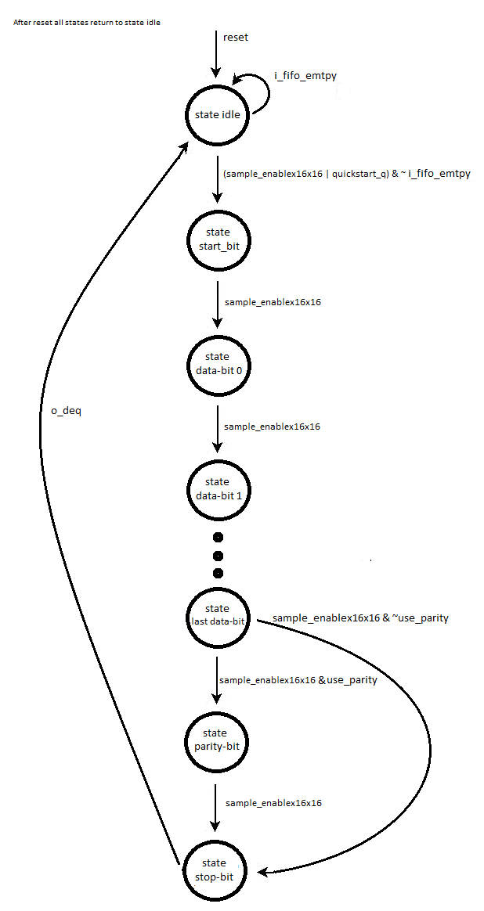
Figure 5.6: State Transition Diagram of uart_transmitter module

State description:
- idle – the reset state of the FSM.
- state0 – give a brief description of state0.
- state1 – give a brief description of state1.
- state2 – give a brief description of state2.
- state3 – give a brief description of state3.

FSM operation:
Describe how this FSM works. Analyze all the transitions and state what happens in each case (e. g. what the next transition is on state1, depending on i_s0_sig0. Make sure that all the transitions are fully explained. Don't forget the white box in the diagram, explaining what happens on reset.

<Subblock_B> (<SUBB>) Subblock
As above

<Subblock_C> (<SUBC>) Subblock
As above

Verification (Optional)

List of Tests
- Test A – Verification of <block name> function.
- Test B – Verification of <block name> function.
- Test C – Verification of <block name> function.
Test | Description
Test A -<testname.v> | Short description
Test B-<testname.v> | Short description
Test C-<testame.v> | Short Description
Table 6.1: List of Tests
The tests should target the functionality claimed in the Functional Description. Plus, any corner cases that might arise.
The tests should be written in a non-regression manner. Meaning that they should be run automated, one after the other. Every time you make a change to the code , you should re-run the tests, and be sure that they are passed.

Detailed Test Description

Test A
The goal of this test is: Describe the overall goal of this test
Unit under test: <module that you are testing>
input vectors (aka inputs to the unit under test)
output vectors(aka outputs from the unit under test)

Describe what the test does.

Test B
As Above

Test C
As Above

