Measurements

Per Tweet Attribute
created_at

in_reply_to_user_id
unique id for the user that wrote the status a status replies to
in_reply_to_screen_name
display name for the user that wrote the status a status replies to
in_reply_to_status_id
unique id for the status a status replies to
Favorited
boolean indicating if a status has been marked as a favourite by the authenticating user
Truncated
boolean indicating if a status required shortening
Contributors | 7 tweets /3.930.004 tweets
Source
application that sent a status
Tweet

Per User Attribute
contributors_enabled
contains an array of user IDs to indicate who contributed to a particular stat u
Favourites_count  number of statuses a user has marked as favourite | 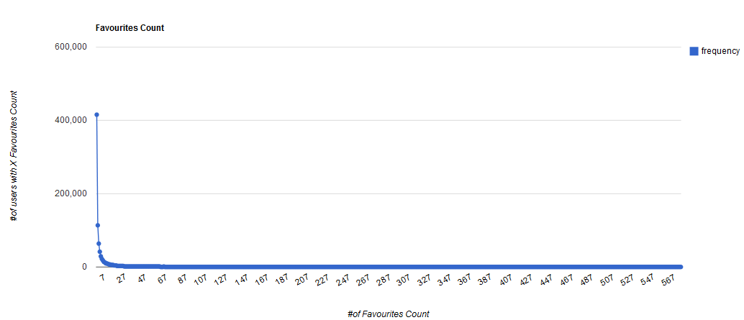
Statuses_count  the total number of status updates performed by a user, excluding direct messages sent | 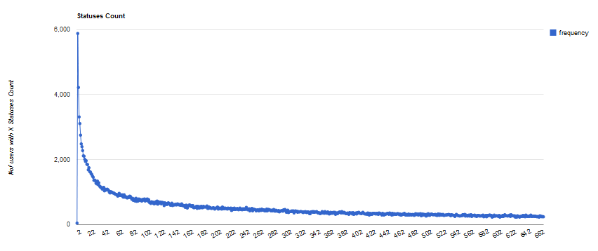
Friends_count  number of users a user is following | 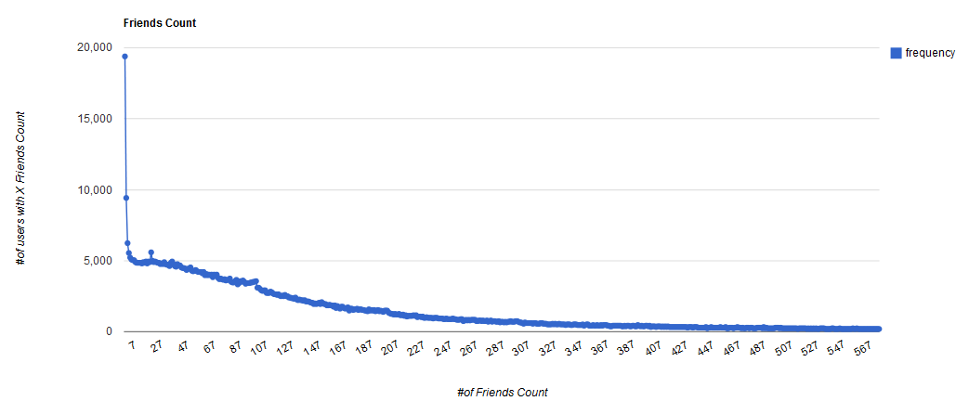
Time_zone
a user's time zone
Lang
the language a user has chosen on Twitter.com for his or her account
Protected
boolean indicating if a user has a protected profile
Followers_count  number of users following a user's updates | 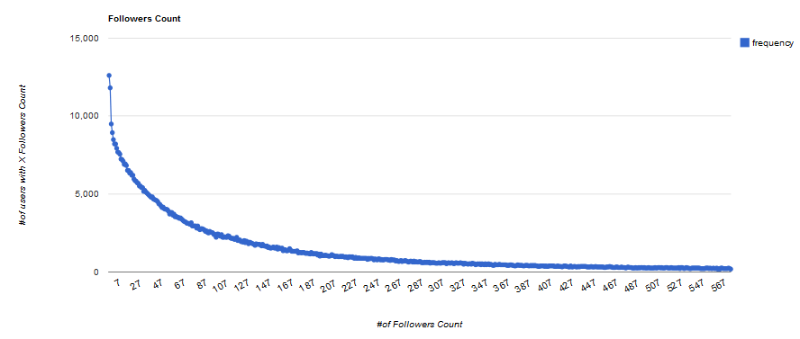
Geo_enabled
whether an individual user has enabled geotagging support on his or her account
Verified
indicates if a user is verified.

Place Attribute
place_type

country_code

country

Geo - Queries
Geo Enabled & Topic Specified

Geo Enabled User & Reply Tweet

User’s location VS real time location

Flotilla Experiment
Most Popular Users
Most Popular Topics co-occur with #flotilla | #Israel  #Flotilla-  #Gaza  #zionism  #thisisisrael  #Gaza:  #BBC  #flotilla...umm,  #QuickPolls  #news  #Turkey  #humanrights  #Iran  #Gaza.  #Palestine  #freegaza  #Israeli  #BDS  #GiladShalit  #Trailer  #flotilla:

More
Top 20 Topics (02/09/2010 – 21/09/2010) | Topic #of tweets Occurrence of term in the year 2010 (google realtime)  #FF 32201 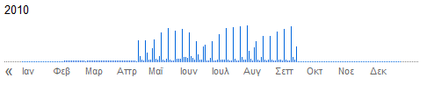  #nowplaying 26553 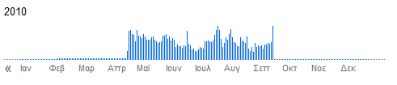  #NP 16308 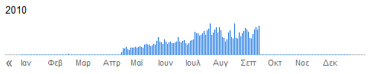  #JamanSD 10836  # 8455  #TeamFollowBack 8208  #fb 8176  #Jobs 6156  #FAIL 5944  #reallymeans 5743  #shoutout 4968  #ZodiacFacts 4688  #VouConfessarQue 4050  #tinychat 4035  #RT 3971  #VMA 3857  #follow 3680  #bieberfact 3659  #nicovideo 3646  #1 3510  #followmeJP 3316  #partiu 3300  #vmb 2946  #qanow 2926  #jfb 2828  #justinbieber 2783  #tcot 2765  #up 2751  #newtwitter 2717  #random 2681
Trending Topics During 02/09/10-10/09/10
TrendAt: Sat Sep 04  1. Stephen Hawking  2. #lessonlearned  3. Duke Nukem Forever  4. #liesguystell  5. Germán Dehesa  6. #andthenihitmydougie  7. #frasestipicamentenatalenses  8. Dehesa  9. #cholaqueserespeta  10. Earl  11. Priority Inbox  12. College Football  13. Holiday Weekend  14. Labor  15. Oil Rig  16. Feriadão  17. Hurricane  18. Jwoww  19. Watchin Jersey Shore  20. Mislukt  21. #nickjonaslive  22. USC  23. Christchurch  24. TGIF  25. Touchdown  26. Sammi  27. Hawking  28. Tiny  29. Fridays  30. Camp Rock | TrendAt: Sun Sep 05  1. Duke Nukem  2. #happybdaybeyonce  3. Year Without Rain  4. Duke Nukem Forever  5. #lessonlearned  6. #2yearspm  7. College Gameday  8. Christchurch  9. Titanic  10. Earthquake  11. Gameday  12. Holiday Weekend  13. Football Game  14. #camprock2  15. Labor  16. #mychemicalromance  17. Beyonce  18. #myclassmates  19. Earl  20. #5millionbeliebers  21. #stickaid  22. Machete  23. #biggestliethatworked  24. Friday night  25. Gators  26. Benidorm Bastards  27. CR2  28. #yomeijimer18  29. College Football  30. #happybirthdaybeyonce | TrendAt: Mon Sep 06  1. Year Without Rain  2. Shoya Tomizawa  3. #happybirthdaygoogle  4. #5millionbeliebers  5. #envenezuela  6. Silvio Santos morreu  7. #biggestliethatworked  8. Camp Rock2  9. Fathers  10. #happybdaybeyonce  11. #mychemicalromance  12. Wayne Rooney  13. CHINELINHO ROBERVAL  14. Without Rain  15. Kissed Henry  16. #rememberwhenjustin  17. Labor  18. Tomizawa  19. #ifblackpeoplewereontitanic  20. Camp Rock  21. LSU  22. #stickaid  23. Marathon  24. Moto2  25. College Football  26. Brunch  27. Cookout  28. Rooney  29. Otm camp rock  30. Boer Zoekt Vrouw

TrendAt: Tue Sep 07  1. #unlikeothergirls  2. One Less Lonely Boy  3. CHINELINHO ROBERVAL  4. #rememberwhenjustin  5. OLLB  6. #iftwitterdidntexist  7. Labor  8. Camp Rock2  9. Parade  10. Angola  11. J♥nas  12. #oksrtter  13. Revis  14. #ifihadonewish  15. #ifblackpeoplewereontitanic  16. Jouvert  17. Parkway  18. #dilmafactsbyfolha  19. Brown Eyed Soul  20. #parejasperfectas  21. Holidays  22. #envenezuela  23. Daybreak  24. Cookout  25. Marathon  26. #laborday  27. Klink  28. Ana Pau  29. BBQ  30. Hail Mary | TrendAt: Wed Sep 08  1. One Less Lonely Boy  2. #unlikeothergirls  3. #ifihadonewish  4. #whythemanonyourjordans  5. Hoarders  6. #iftwitterdidntexist  7. Tyrod Taylor  8. Boise  9. Kellen Moore  10. #tubestrike  11. #alliwant  12. VTech  13. Parkway  14. Labor  15. Cliquem  16. #parejasperfectas  17. Wozniacki  18. Lou Holtz  19. J♥nas  20. Parade  21. #souljaboyisboutasgangstaas  22. Virginia Tech  23. Google Doodle  24. #11ften  25. #mexicanosalgritode  26. Sharapova  27. Joran  28. #gagadaily  29. About Soulja Boy  30. #happybdaygustav | TrendAt: Thu Sep 09  1. #alliwant  2. Shana Tova  3. #dontarguejustacceptit  4. Eid  5. #whotoldyou  6. Anarchy  7. Google Instant Search  8. Willow  9. Koran  10. Burning  11. Rosh  12. #souljascokehabit  13. Derren Brown  14. Quran  15. #famososdeantes  16. Loge  17. Sons  18. Jewish  19. 2NE1  20. Suge Knight  21. #semeuke  22. Camp Rock Perdeu  23. Pastor  24. #11ften  25. Souljaboy  26. iOS  27. Skool  28. Homework  29. Game Center  30. Whip | TrendAt: Fri Sep 10  1. Rich Cronin  2. Shana Tova  3. Portnoy  4. Marvin Sapp  5. #footballerfilms  6. Eid Mubarak  7. LFO  8. Jeepers Creepers  9. #alliwant  10. #whotoldyou  11. Google Instant  12. Minal aidzin walfaidzin  13. #abortionclinicplaylistsongs  14. Dream Theater  15. Expeditie Robinson  16. Administrador  17. Iyi Bayramlar  18. Quran burning  19. Koran burning  20. Instant Search  21. Hellcats  22. Willow  23. Quran  24. Game Center  25. #ghettocollegecourses  26. Koran  27. #twipple_kuji  28. Ied  29. #dontarguejustacceptit  30. Aidin

The trending topics found in the first week of September (those with a hashtag) exist in our database but in a lower volume. As we expected, we failed to recognize trends based on the popularity of a hashtag, but we found some very common hashtags.

